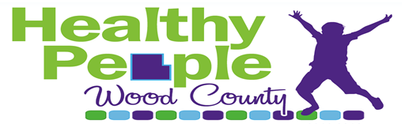
Prioritizing Community Health Needs for Wood County

Review the data and information provided for the 22 health focus areas. List the 3 health areas (in any order) that are most important to you for each question. At the end of the worksheet, list the overall top 3 health areas in need of improvement.

Health Focus Areas  Chronic Disease  Oral Health  Communicable Disease  Mental Health  Injury  Violence  Alcohol  Drugs  Physical Activity  Healthy Eating  Food Security & Hunger  Tobacco  Reproductive and Sexual Health  Environmental & Occupational Health  Access to Care  Healthy Growth & Development  Immunization  Quality of Care  Education  Employment  Income  Family and Social Support  Other (write in option) |  | Which health areas have the largest community impact?  Consider which areas have a high number of people affected, which areas affect certain groups more than others, and how big the problem is in our community.  I think the 3 areas with the largest community impact are:  1.______________2. ______________3. .______________
Which health areas have the most serious impact?

Which areas result in disability, death, have long-term effects, or need immediate action? Is the problem getting worse?

I think the 3 areas with the most serious impact are:

1.______________2. ______________3. .______________

Which areas is our community ready to change?

Discussion: Will the community accept new or additional programs? Are new programs wanted in certain areas? Is change on a local level feasible?

I think the 3 areas with the greatest community acceptance are:

1.______________2. ______________3. .______________

In which areas can changes be made over a reasonable timeline?

Discussion: Can change be accomplished in less than 5 years? Are there areas with longer timelines that need immediate attention?

I think the 3 areas with a reasonable timeline are:

1.______________2. ______________3. .______________

